5G/6G Communication Systems- ECA5601 (LAB)
Student Name: A.SAI KIRAN
Reg no: 192312672L
Experiment 9: Massive MIMO Capacity vs SNR and Gain Using MATLAB
Aim: To analyze the performance of a Massive MIMO system by studying channel capacity,
signal-to-noise ratio (SNR), and antenna gain using MATLAB.
Objective 1:
Program:
clc;clear;close all;
snr = 0:5:30;
snr_linear = 10.^(snr/10);
capacity = log2(1 + snr_linear);
figure;
plot(snr,capacity,'-o','LineWidth',2,'MarkerSize',6);
grid on;
xlabel('SNR (dB)');
ylabel('Channel Capacity (bps/Hz)');
title('Channel Capacity vs SNR');
Output:
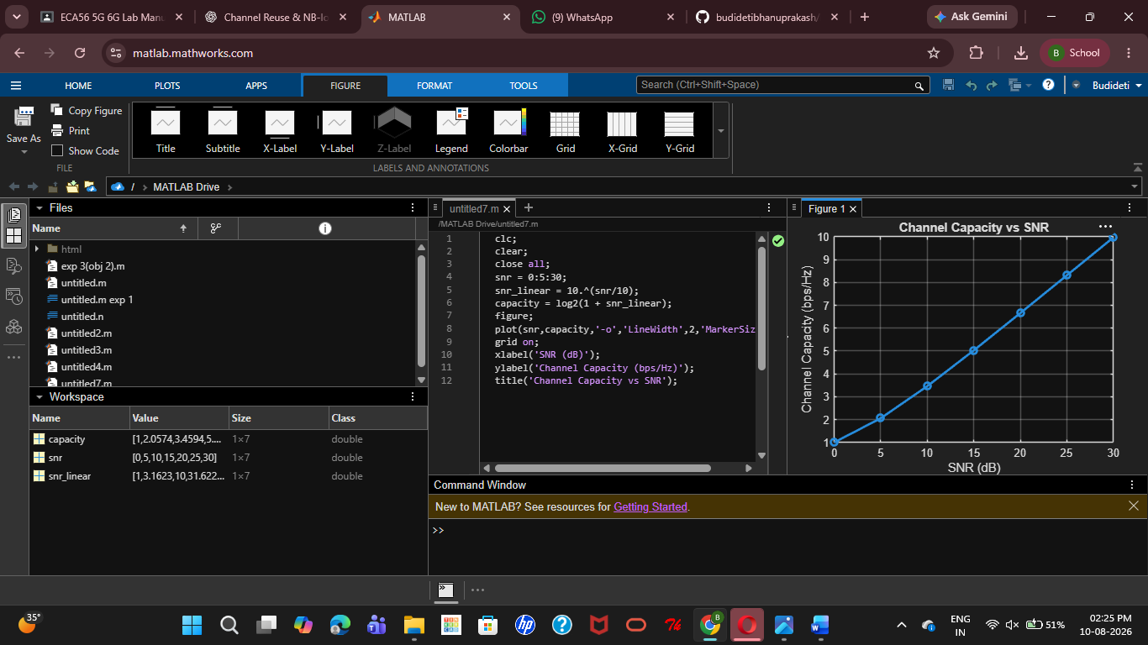
Objective 2:
Program:
clc;
clear;
close all;
snr = 0:5:30;
snr_linear = 10.^(snr/10);
capacity = log2(1 + snr_linear);
figure;
plot(snr,capacity,'-o','LineWidth',2,'MarkerSize',6);
grid on;
xlabel('SNR (dB)');
ylabel('Channel Capacity (bps/Hz)');
title('Channel Capacity vs SNR');
Output:
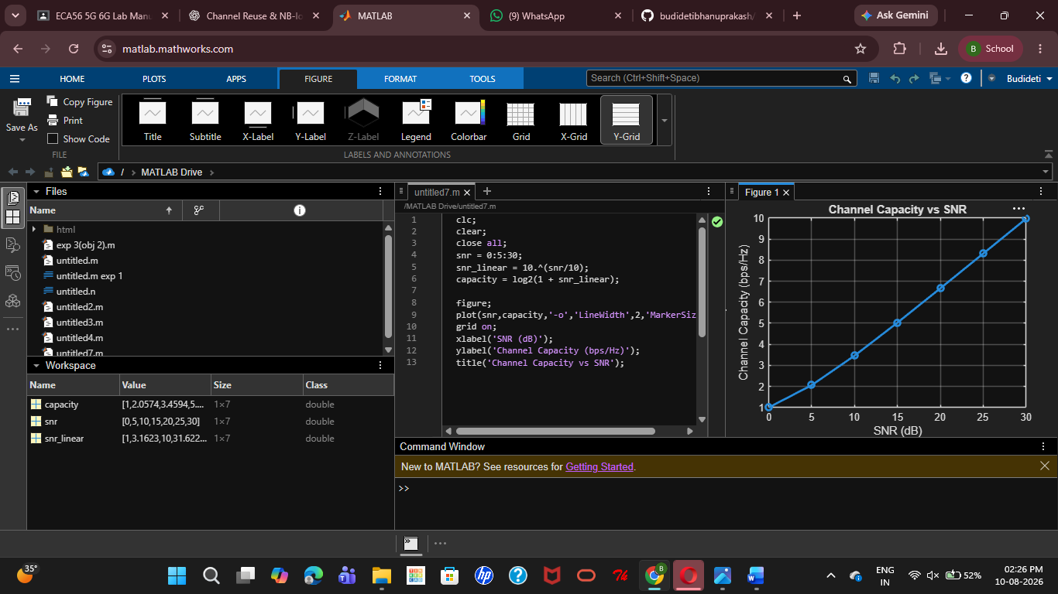

Objective 3:
MATLAB Code:
clc;
clear;
close all;
antennas = [4 8 16 32 64]; % Number of Antenna Elements
gain = 10*log10(antennas); % Antenna Gain (dB)
figure
bar(antennas, gain)
grid on
xlabel('Number of Antenna Elements')
ylabel('Antenna Gain (dB)')
title('Antenna Gain for Different Antenna Array Sizes')
Output:
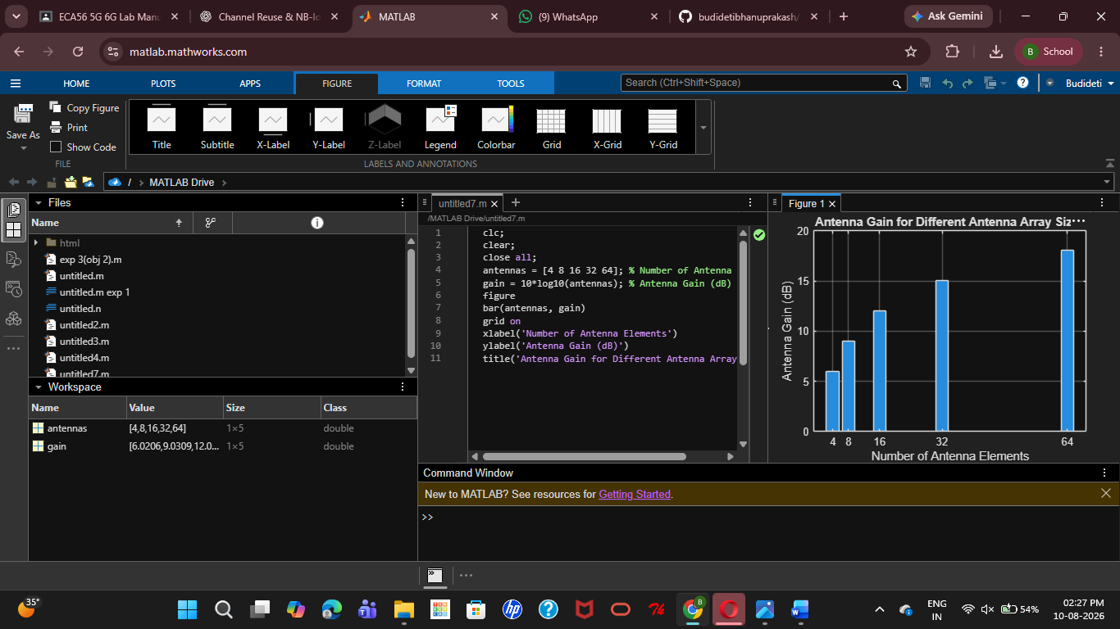
Result:
The Massive MIMO system was successfully analysed in MATLAB, showing that channel capacity and communication reliability increase with SNR, while increasing the number of antenna elements improves antenna gain and overall system performance.

